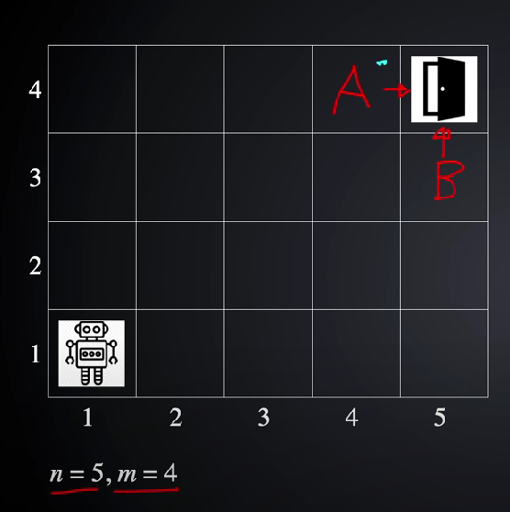

Robot can only move **right** and **top**.You need to calculate all unique paths for exit.